**Spam Classification**

1. Decision Rule

If  >=  classify as spam,

Else classify as ham

1. Posterior probability

 = *

 = *

1. Prior probabilities

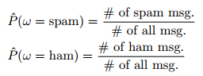

1. Class-conditional probabilities:
2. Mutli-variate Bernoulli Navie Bayes
3. Multinomial Naïve Bayes